SCHOOL RECORDING STUDIO SCHOOL EDITORIAL

Dubňany elementary school, p.o.
Hodonínská 925
696 03 Dubňany

Contents:
Annotation of the project 3
Price calculation 4
Equipment overview 5
Pinnacle Studio 24 9
Students involved in the project 13
How to do it 17
Project outputs 22
Thanks 23

Annotation of the project
1. Project plan
- Main purpose is motivating pupils to use technology for self-presentation and presentation of the school and the region.
- Selection and purchase of suitable equipment
- Acquainting students with technology and the possibilities of its use.
- Providing a space for students' creative activities, motivation, consultation with the team.

2. Project objectives
- Pupils will learn to operate a classic video camera and a Go-pro camera. They will film and then download captured footage to a notebook or desktop PC, where they cut and edit the image and sound. They will learn to film reports from the school and the village. Students will create demonstration and instructional video tutorials. They can also try to film acted or documentary films. They will master self-presentation skills and perform in front of an audience and on camera. They will work together in editorial teams. They will present their point of view on topics that are important to them.
- Control recording technology (video camera and its control)
- Process the video recording (edit, sound, edit image)
- Present using a data projector (play the video presentation)
- Perform and communicate in front of an audience
- Find and process interesting topics, argue on these topics correctly

Price calculation

We received 100,000 CZK as part of the project for the purchase of the necessary equipment. This amount is quite enough for the equipment for medium size classroom equipment.
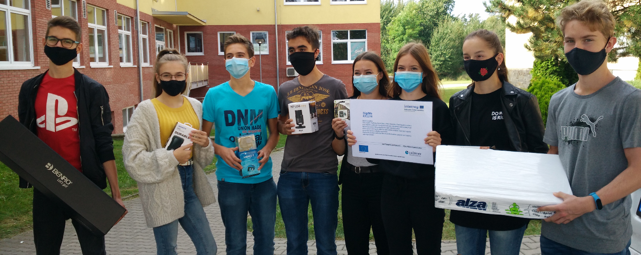
We have planned the following equipment
Camera Panasonic HC-V770EP-K black | 1 | 9 592,00 CZK
Card 128gb sdxc | 2 | 699,00 CZK
Action camera Go-Pro | 1 | 5 703,94 CZK
HDD | 1 | 1 935,16 CZK
Studio microphone | 1 | 2 580,00 CZK
Spare battery for the camer | 1 | 3 990,00 CZK
Tripod | 1 | 8 990,00 CZK
Notebook Dell Vostro | 1 | 17 882,59 CZK
PC | 1 | 22 490,00 CZK
Monitor | 1 | 5 315,00 CZK
Directional microphone | 1 | 4 990,00 CZK
Telescopic pole for microphone | 1 | 2 990,00 CZK
Video editing software – Pinnacle Studio 24 | 2 | 6 350,00 CZK

Equipment overview

- Panasonic HC-V770EP-K black (+ 128gb sdxc card + battery)
- A classic video camera for shooting basic static reports, scenes and clips. It impresses with the durability of the supplied battery, high-quality Full HD video up to 50p. Delightful and expressive optical image stabilization O.I.S., easy operation and clear settings via the touch LCD display. Its compactness and low weight (approx. 400 grams with battery and card) is pleasant as well. All controls are in the right places, within easy reach of the index finger (zoom rocker and photo shutter) and thumb (video shutter). The rest of your fingers fit right between the microphone in front and the aforementioned controls on the top back of the camera. The device is entirely made of matte black (or white on the surface) plastic. Automatic focus works reliably, and you only need to resort to manual adjustment in poor lighting conditions, or when you want to be sure that the image does not momentarily defocus at an inopportune moment (so-called breathing) and thereby spoil an unrepeatable shot. More experienced users will prefer to manually adjust the focus, which is done by activating the touchscreen from AF to MF and then turning the multi-function dial near the lens. The zoom options are quite rich in this device, as far as setting options are concerned, but in practice the most useful is t;he 20x optical zoom, which does not degrade the image quality of the recording. USB, HDMI or A/V cables are available for connection or you can simply use WIFI. There is a microphone in the front that can capture sound in stereo 2.0, MONO or multi-channel 5.1. The battery pleasantly surprises by its durability – approx. 90 minutes of 1080/50p video. We bought two just to be sure.

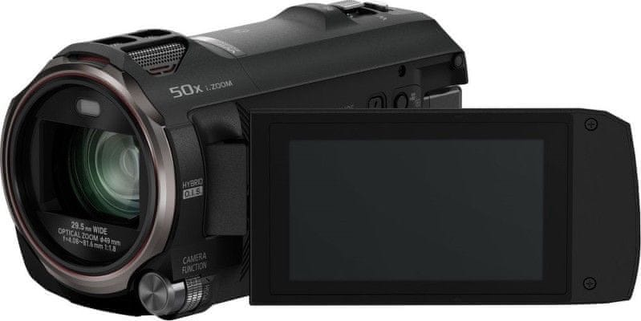
- GoPro Hero 7

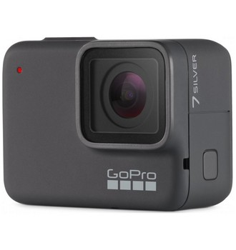
Action outdoor camera from the world-famous manufacturer GoPro. We use it for dynamic shots or when we don't want to carry a big camera with us. In addition to recording in ultrafine 4K resolution, it boasts an overhaul of video stabilisation. Other useful functions are the possibility of direct transmission to social networks, eight-fold slow-motion mode, fine-tuned time-lapse even without a tripod, accurate GPS or convenient voice control. Not always easy to pair with a smartphone and increased durability and water resistance to a depth of an incredible 10 metres without a case. GoPro HERO7 Black brings HyperSmooth stabilisation, thanks to which you can look forward to smooth shots in any action. No expensive gyroscopic tripods, no worries about low-quality recording. So that you don't have to interrupt the current activity for each photo, start or stop filming, GoPro supports simple voice control. The camera recognizes up to 16 different commands and you can add short comments without any touch.

3. Microphone
- RODE NT-USB mini studio microphone
- RODE NTG1 directional microphone + telescopic pole

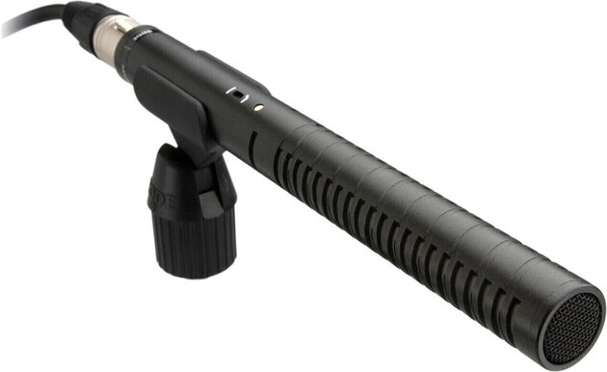

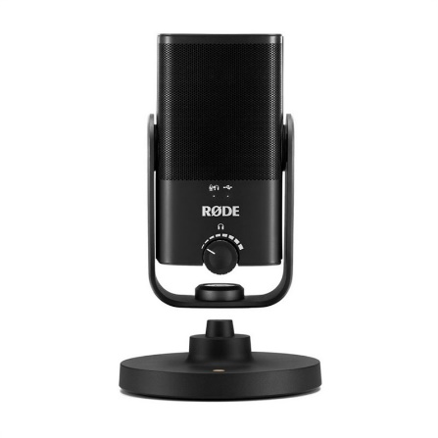

- BENRO tripod + S4Pro video head
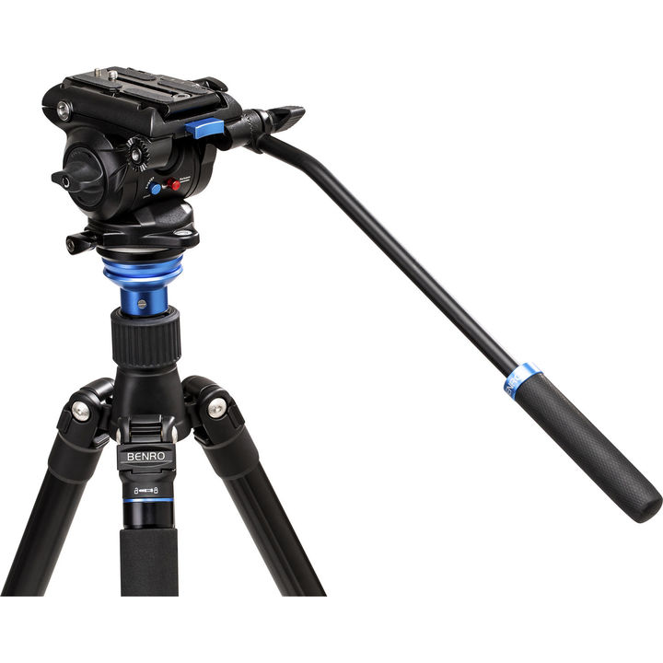
A tripod is one of the most requested accessories for cameras and camcorders, its use usually has a very positive effect on the resulting recording quality. It should be firm and stable. This is the only way to prevent accidental shaking. The quality of the material used is also important. Better tripods have adjustable and extendable legs.
No less important is the fluid head of the tripod for smooth capture with movement. We have the Benro S4Pro: a versatile fluidic counterweight video head capable of handling equipment weighing up to 4 kg.

- LED video light with colour temperature control – VIJIM VL-1
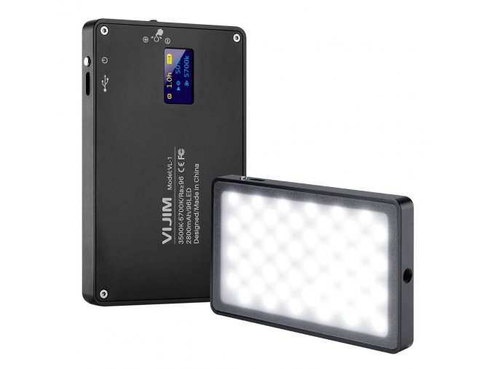
- Powerful durable LED video light that can be recharged using the USB-C connector. It is made of aluminium and prepared for tougher handling. It provides continuous regulation of intensity and also the colour temperature. You can see everything on the well arranged colour display. Colour temperature is from 3500K to 5700K - 96LED.

- Preview monitor – FEELWORLD S55 5.5" IPS LCD
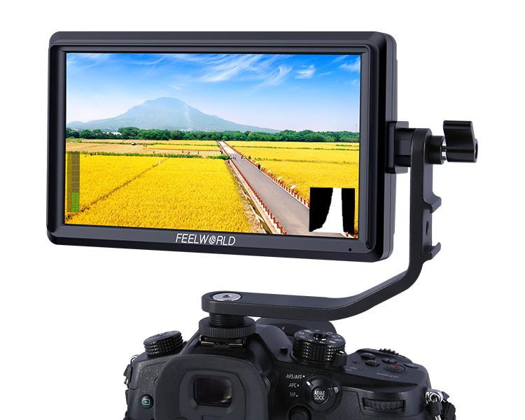
5.5" IPS LCD camera monitor with a native resolution of 1280x720 and weighing only 175 g is an ideal helper for building compact camera rigs with stabilisers, etc. The miniature but powerful 5.5" camera monitor is designed for small DSLR/DSLM cameras that enriches it with a number of preview functions, including false colours, focus assistance, pixel to pixel, listening to sound, guides etc.

- And other equipment that does not need to be introduced:

- Dell Vostro netbook
- PC + Monitor
- External HDD

- An essential part is the software on which we will process the recorded videos.
- We chose a proven SW – Pinnacle Studio 24 (see next chapter)

Pinnacle Studio 24
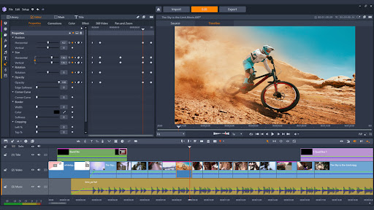
Pinnacle Studio is a high-quality video editing program suitable for both beginners and advanced users. This software allows you to edit videos, helps with image, colour, sound, special effects, etc. In addition to basic and advanced editing tools, it offers a library full of intuitive templates that you can use as you like. Working in the program is facilitated by its clarity, thanks to which you can quickly find your way around, as well as various keyboard shortcuts to speed up the process. You can shoot and edit your videos on multiple platforms. You can film on a computer or a web camera and record sound – music, spoken word, etc. The Czech language is a big advantage of the Pinnacle Studio program.

What we were missing was a free version, which we searched for in vain. We really missed the opportunity to try out how the software works before we buy it, and we're certainly not the only ones.

Pinnacle Studio works very well. Its user interface is very clear and you will find your way around it quickly. The work is also facilitated by intelligent editing tools, which can be double-clicked to save preferences, export grouped clips or create your own shortcuts. Basically, it can be said that the tools are as powerful as in a professional editing program.
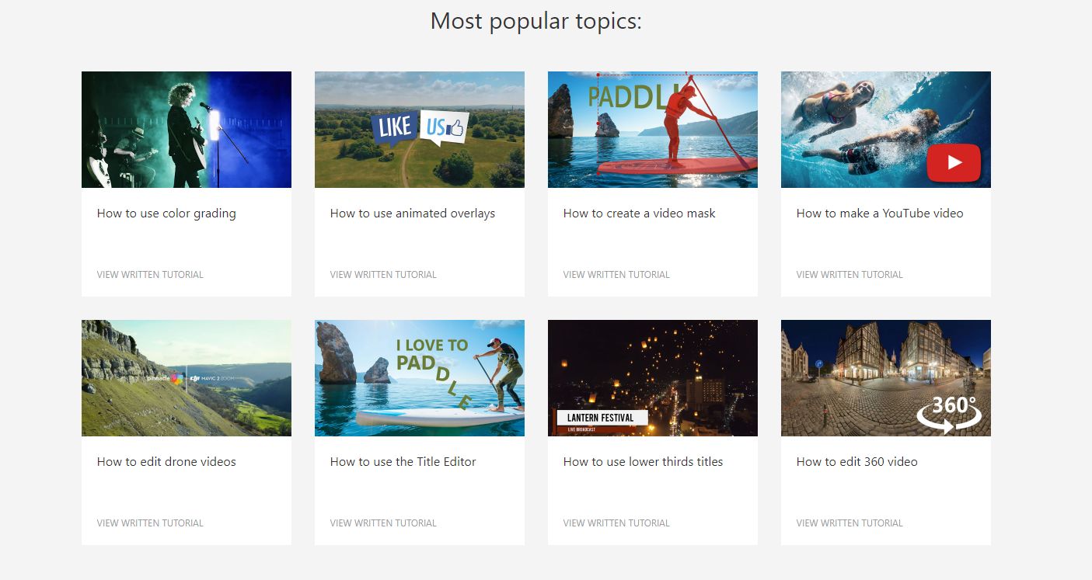
If you do find yourself lost, the Pinnacle Studio website has an extensive selection of tutorials to help even complete beginners quickly learn and develop skills. The video courses will teach you basic video editing, but also advanced techniques, applying effects, etc. These instructional videos are free and thanks to them you can improve your work in this software from the comfort of your home, whenever it suits you.
(https://www.pinnaclesys.com/en/tips/)

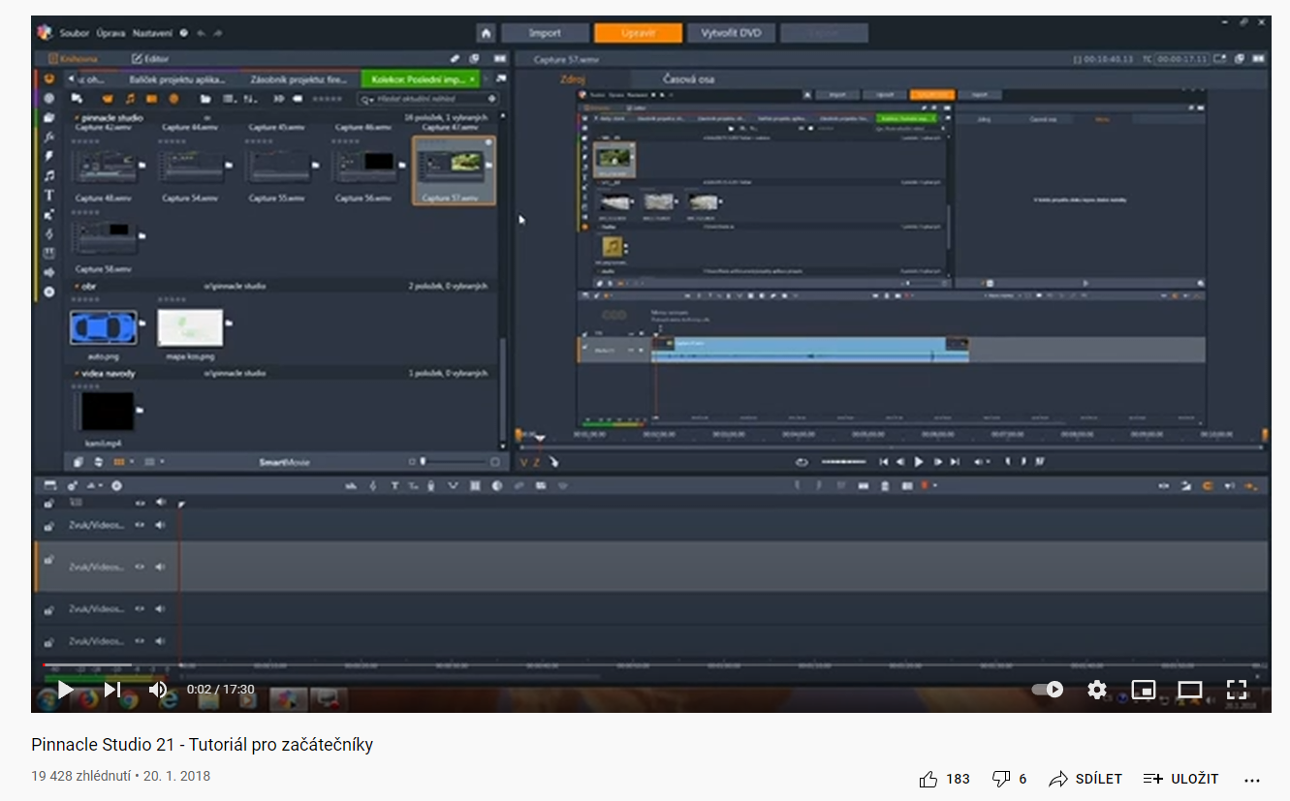
Similar tutorials can be found on Youtube.com
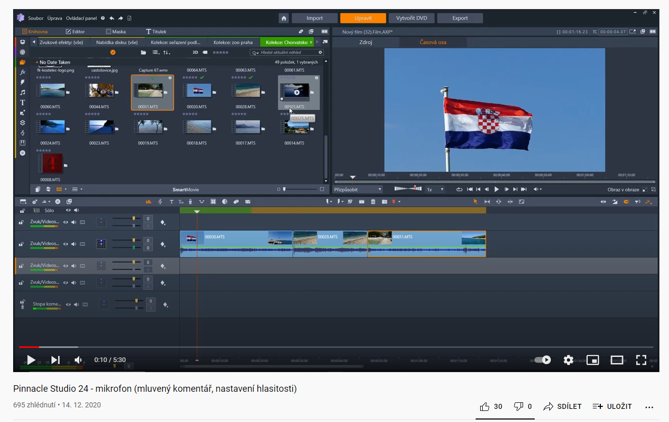
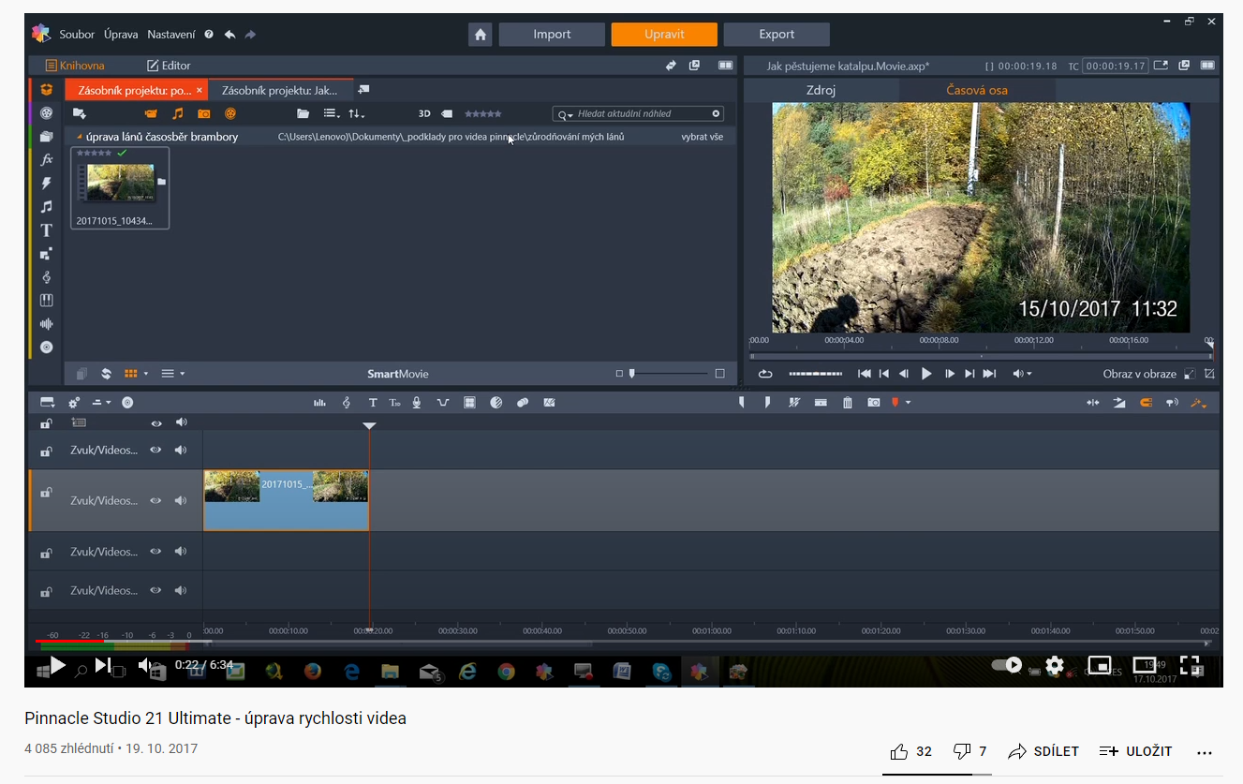
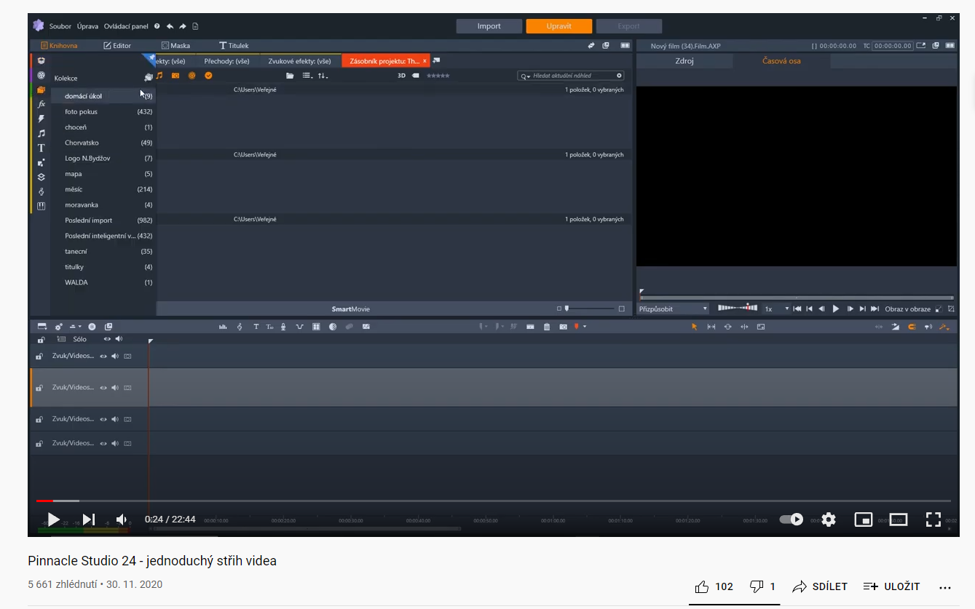
https://www.youtube.com/channel/UC0OHww4AoaKc676B6d9Ev0Q - Jan Barvínek

Students involved in the project

At the beginning, we had twelve enthusiastic students who wanted to participate in shooting films and editorial shots. These students are from ninth grade. Over time, they formed a group of six enthusiasts who devoted themselves fully to this hobby. Younger classmates then joined them during the school year. Unfortunately, the Covid epidemic interfered with everything and the promisingly started project started to stall. Government restrictions, curfews, school suspensions and other restrictions came. Even so, we managed to keep the team and complete some projects. Recently, more enthusiastic sixth graders have appeared, which is a great promise of continuation even though the DigiMe project as such has come to an end.
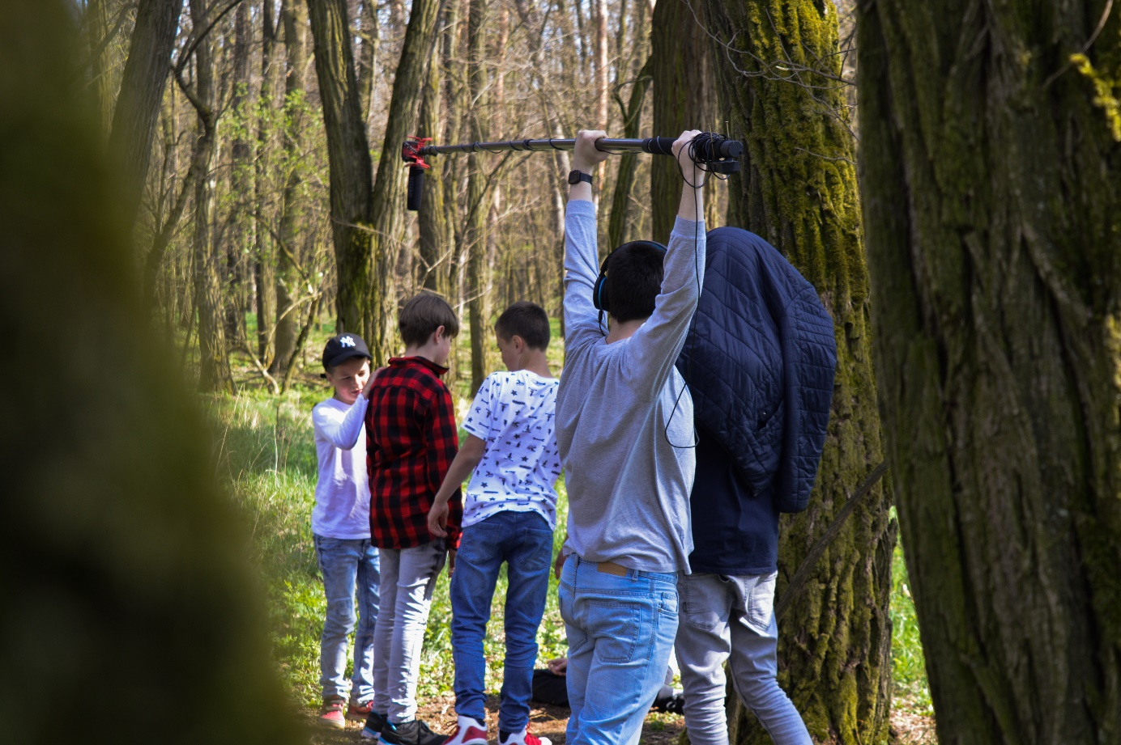

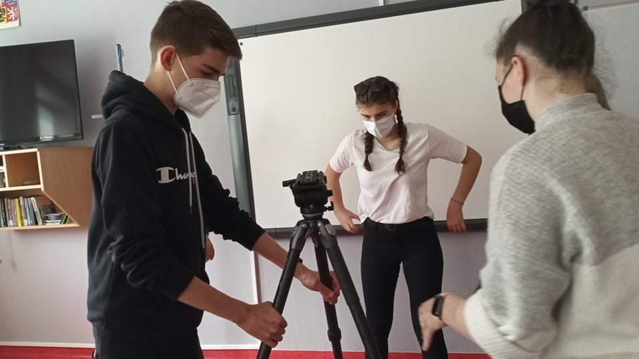
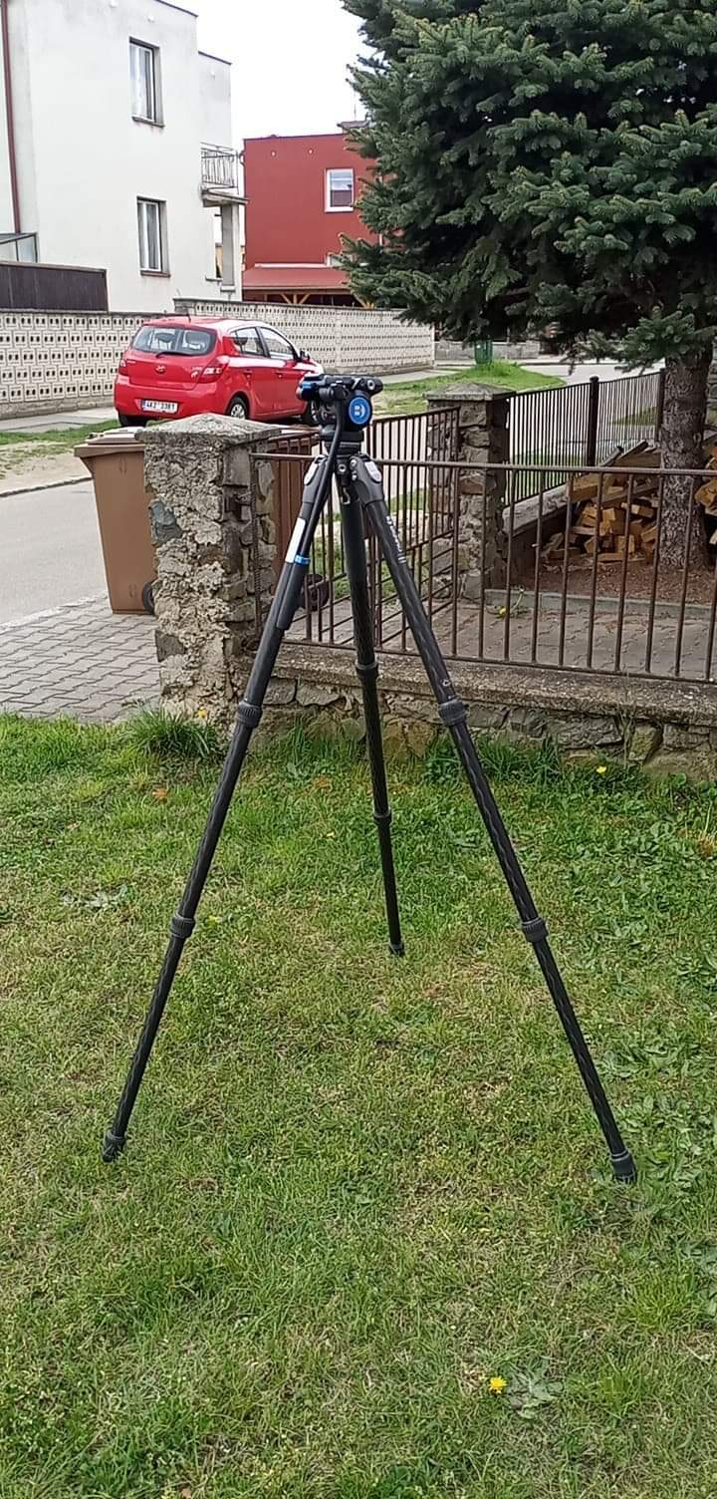
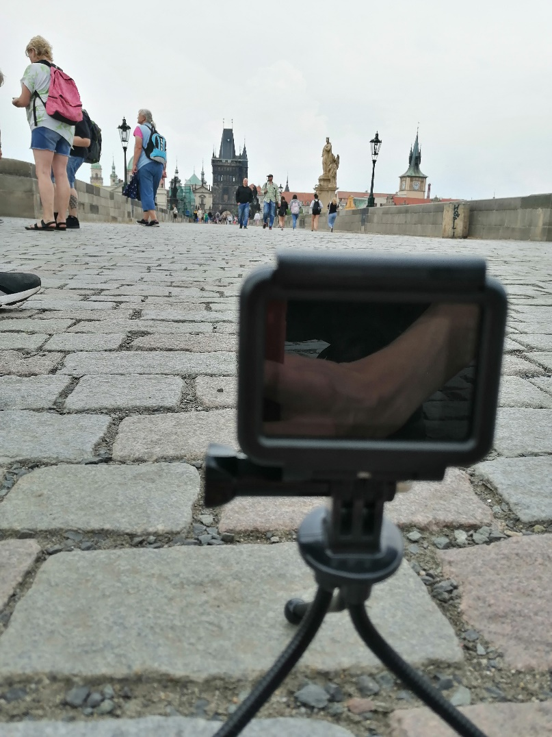

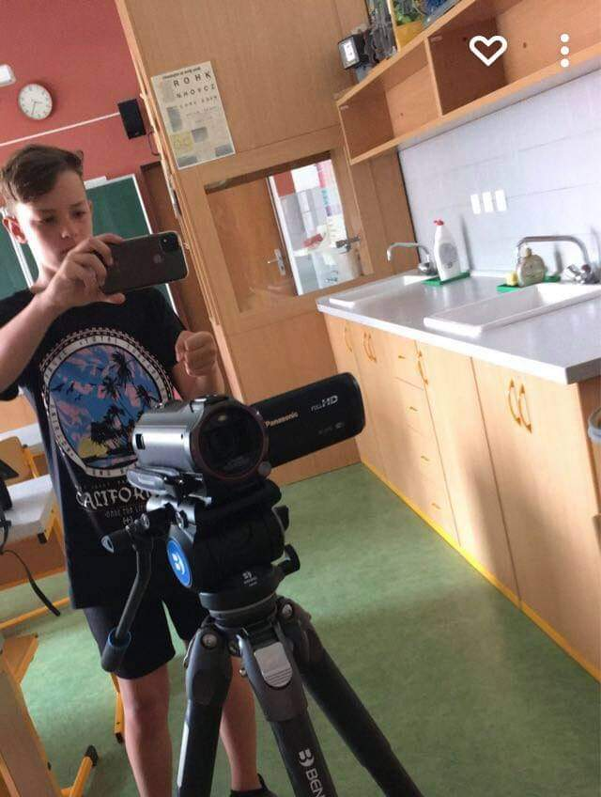
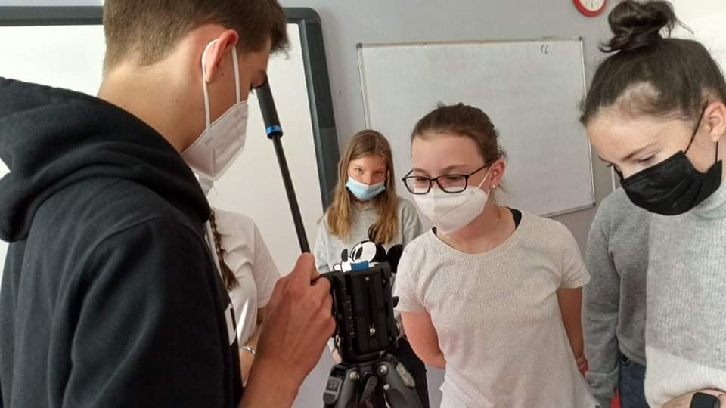

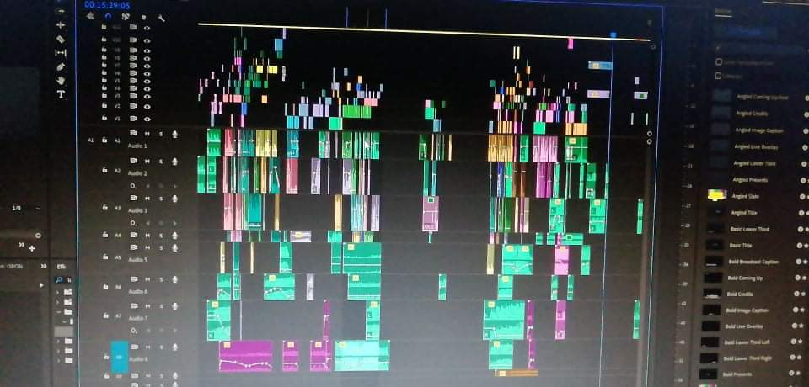
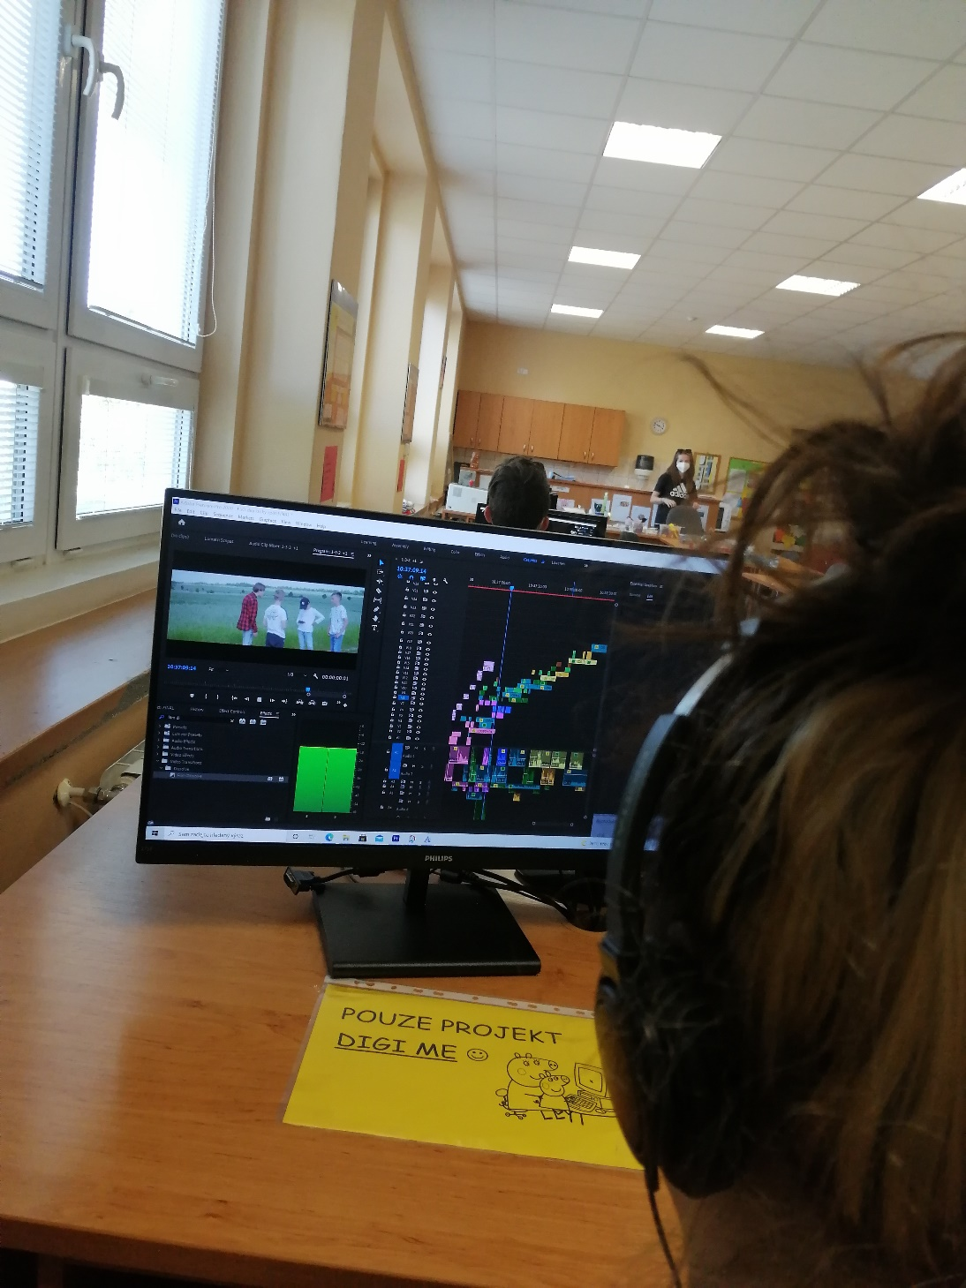
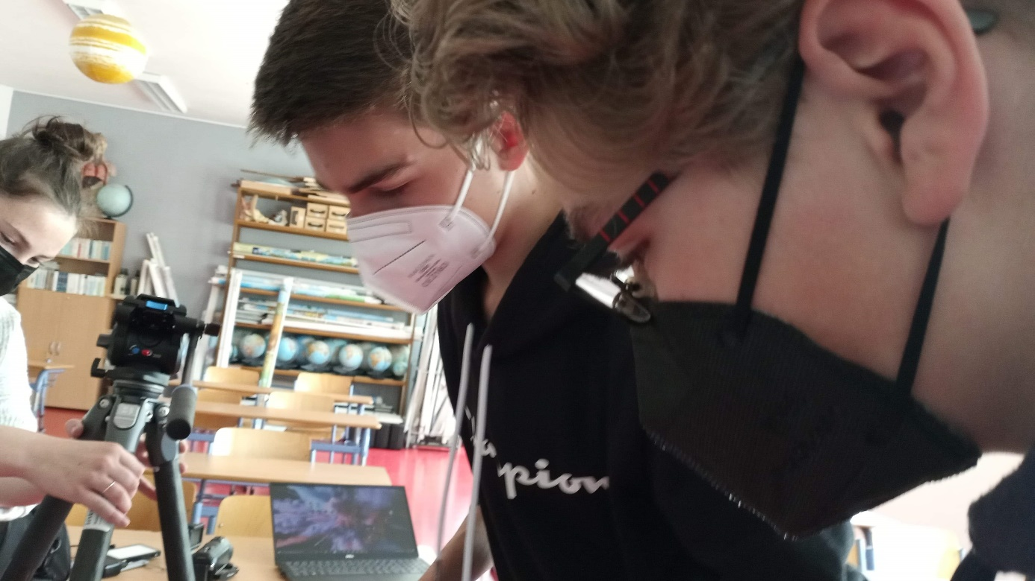
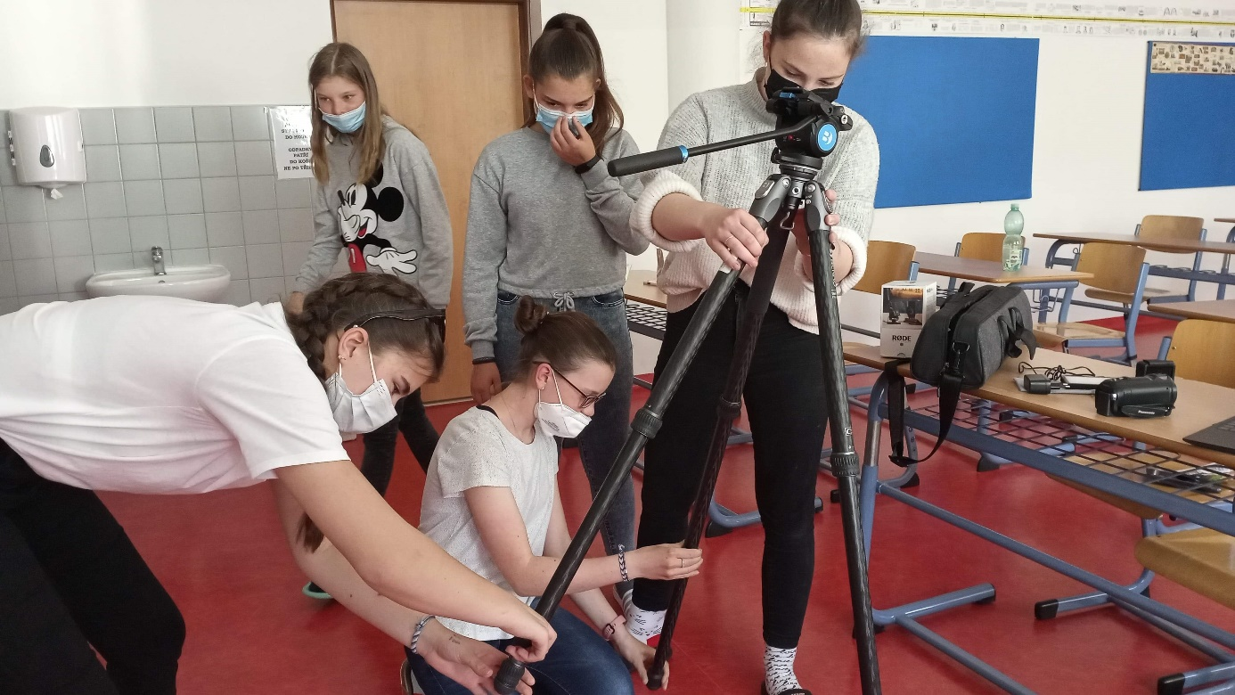

How to do it
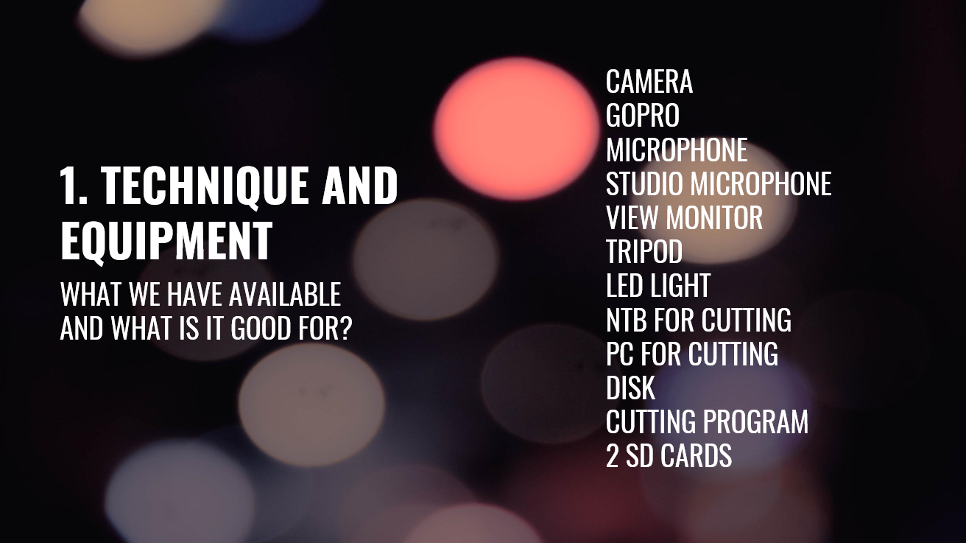A few simple tips from our student Filip Kratochvíl on how to deal with shooting.
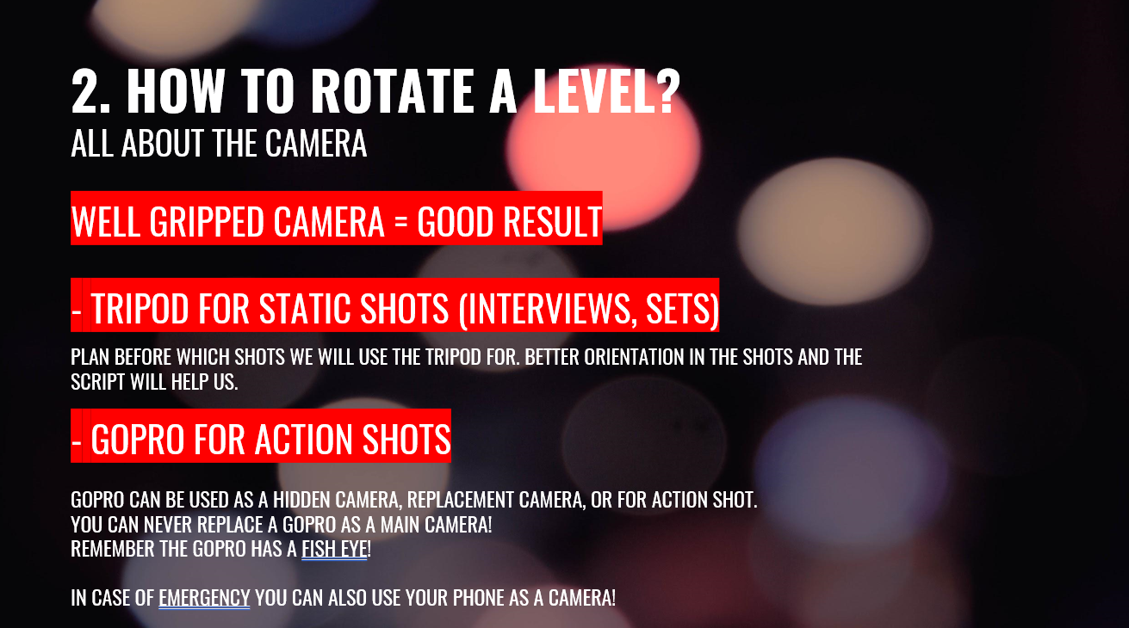
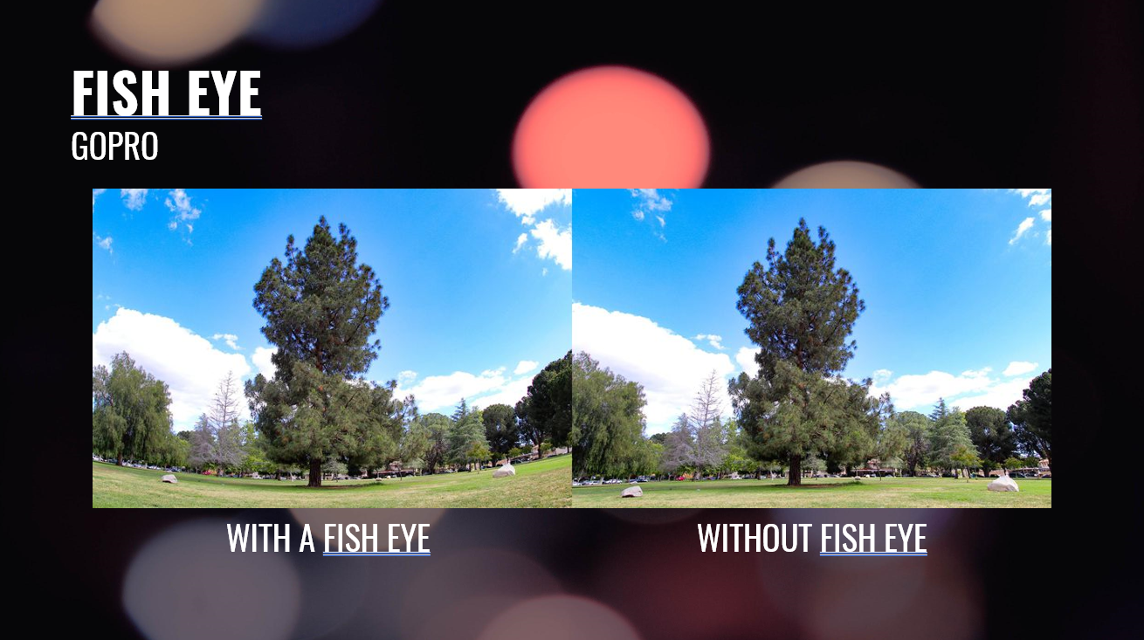
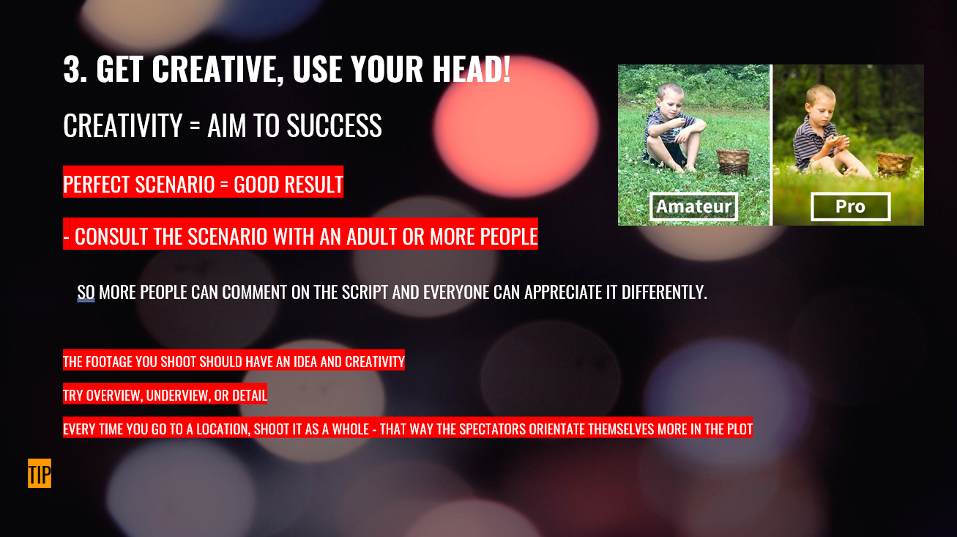
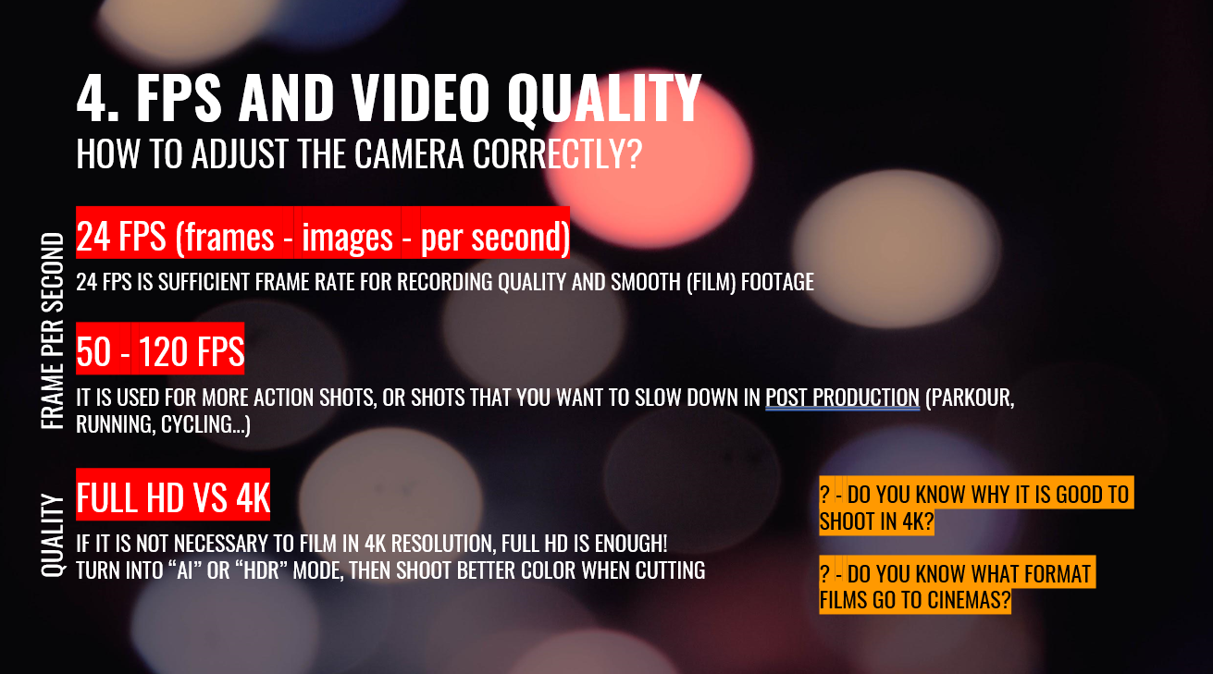
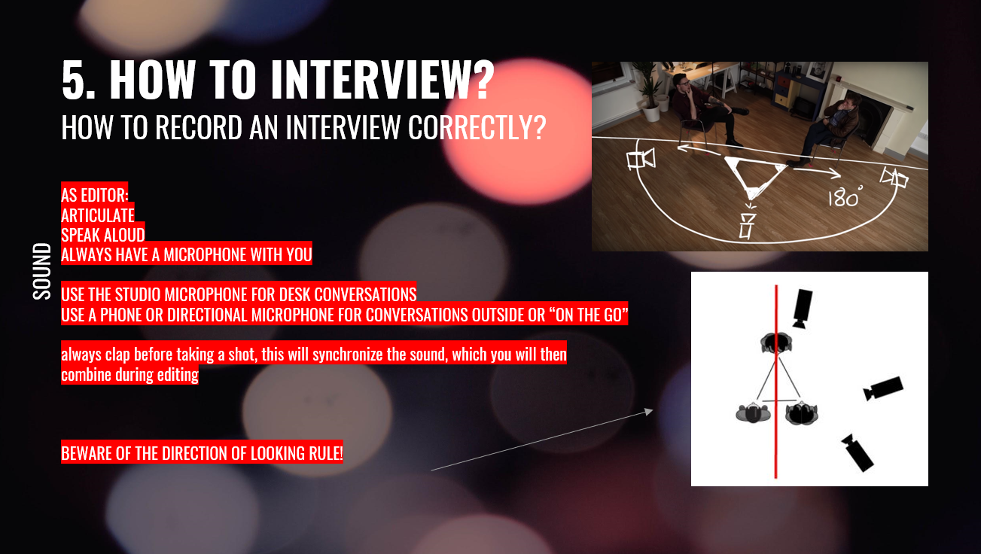
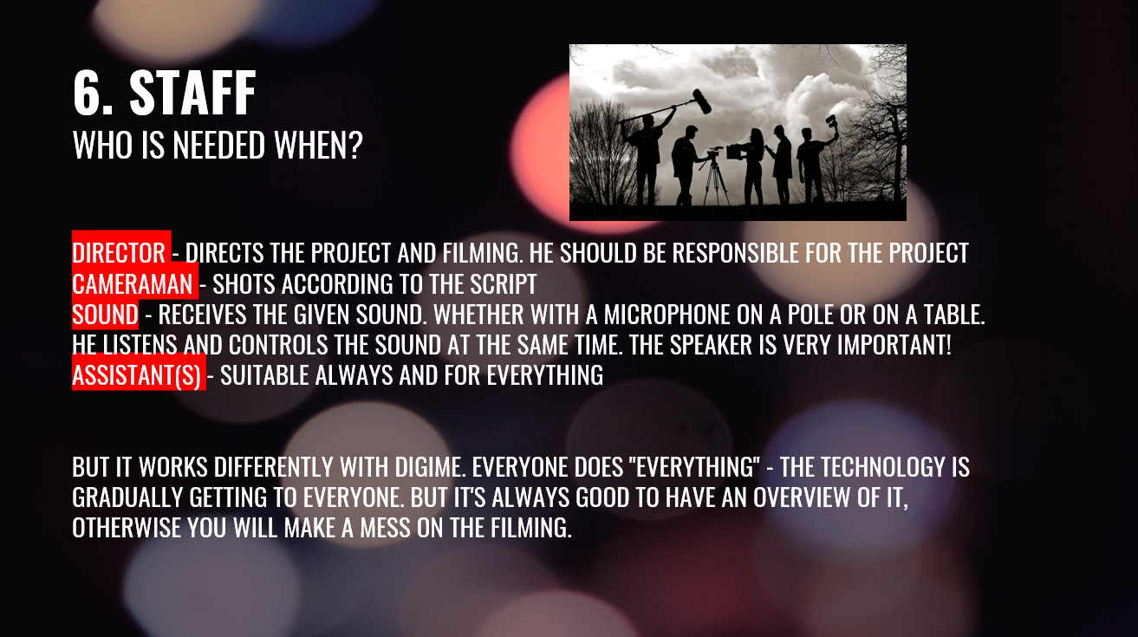
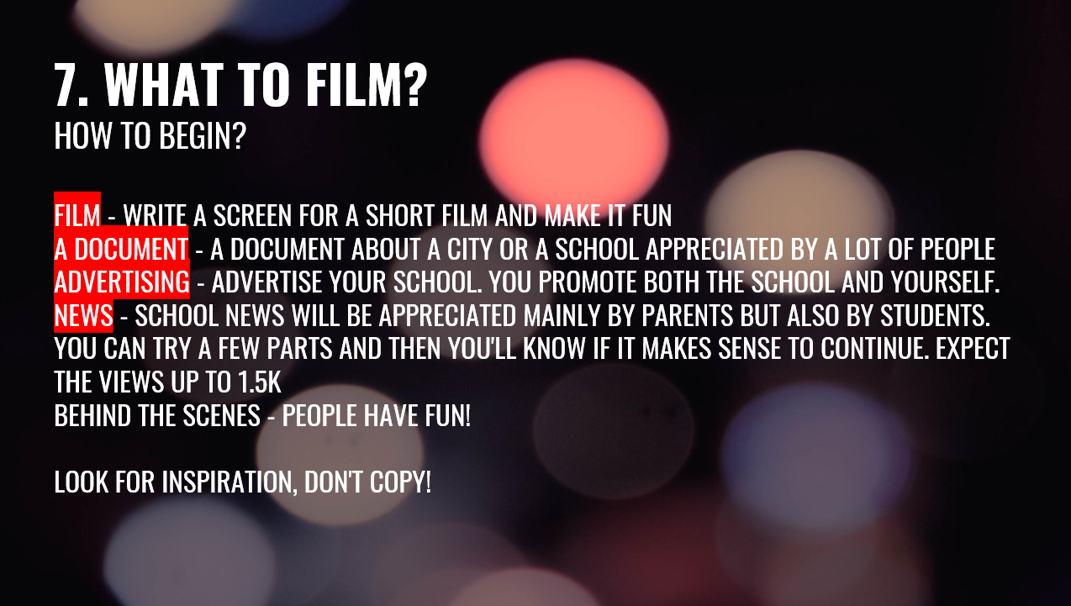
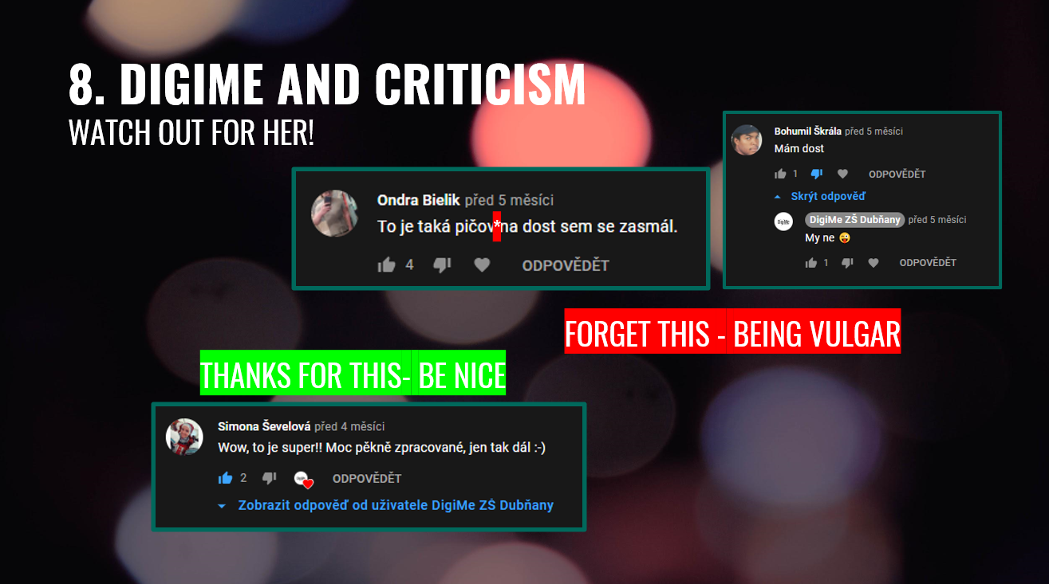
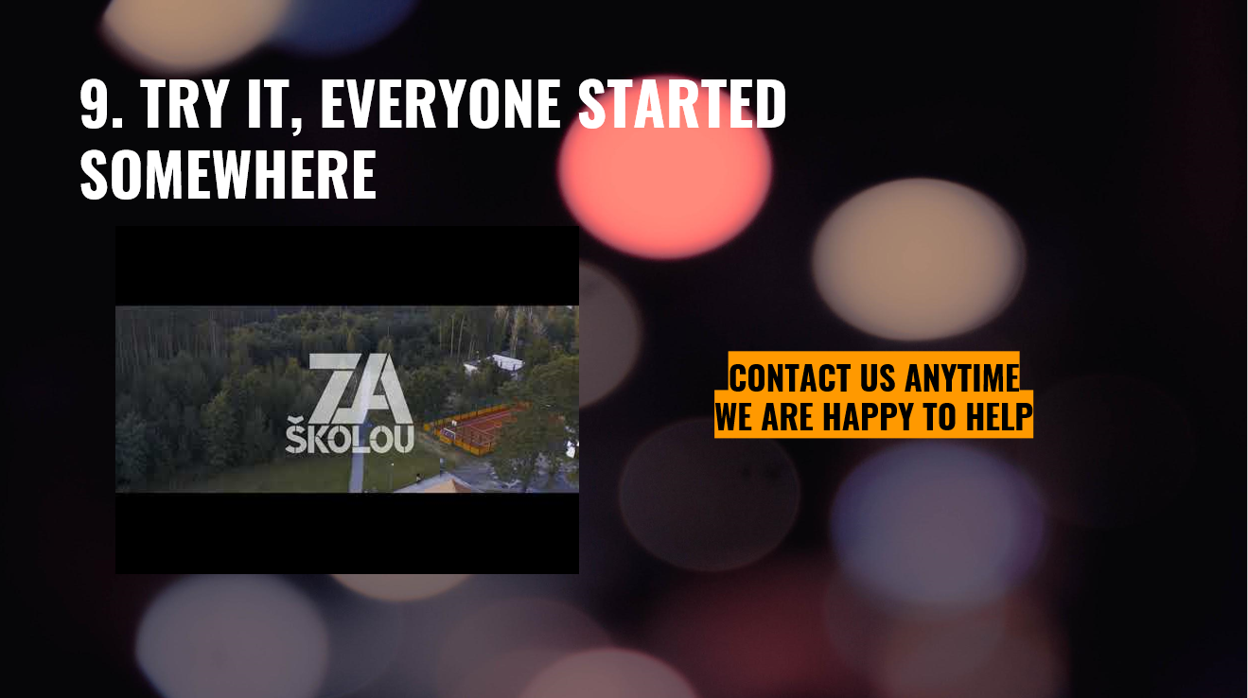

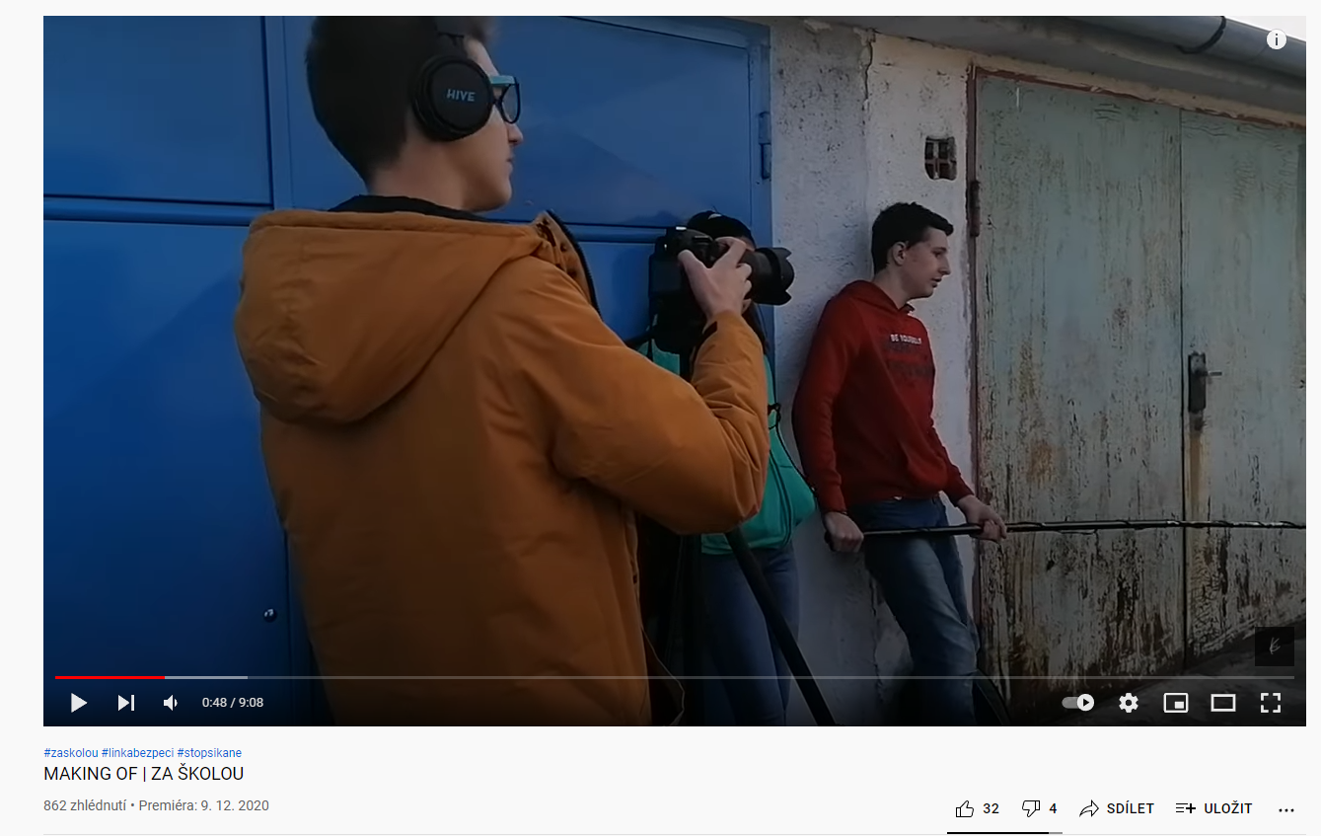
Project outputs
https://www.youtube.com/watch?v=1iaFcJDHPJM
Become a journalist!
https://www.youtube.com/watch?v=OTHLyrLDXnk
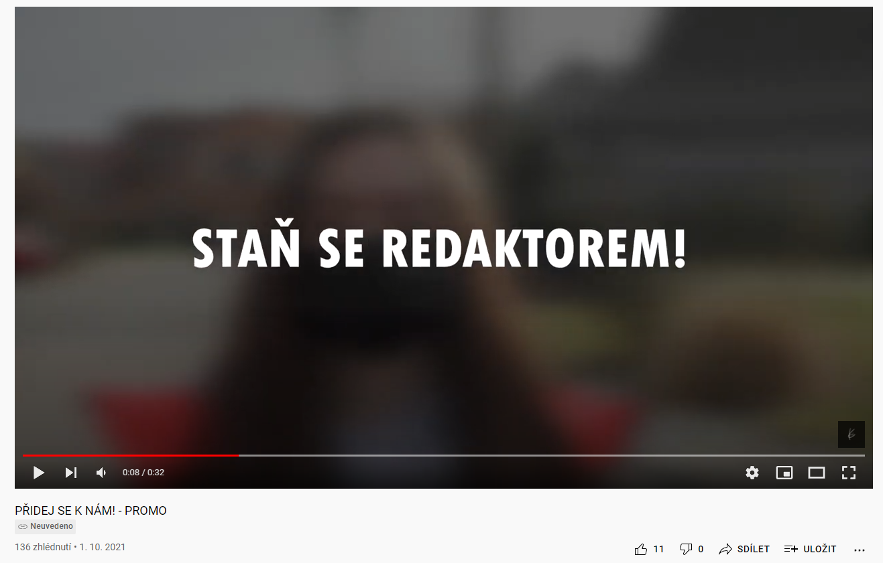
https://www.youtube.com/watch?v=1Qw3tMIzABA

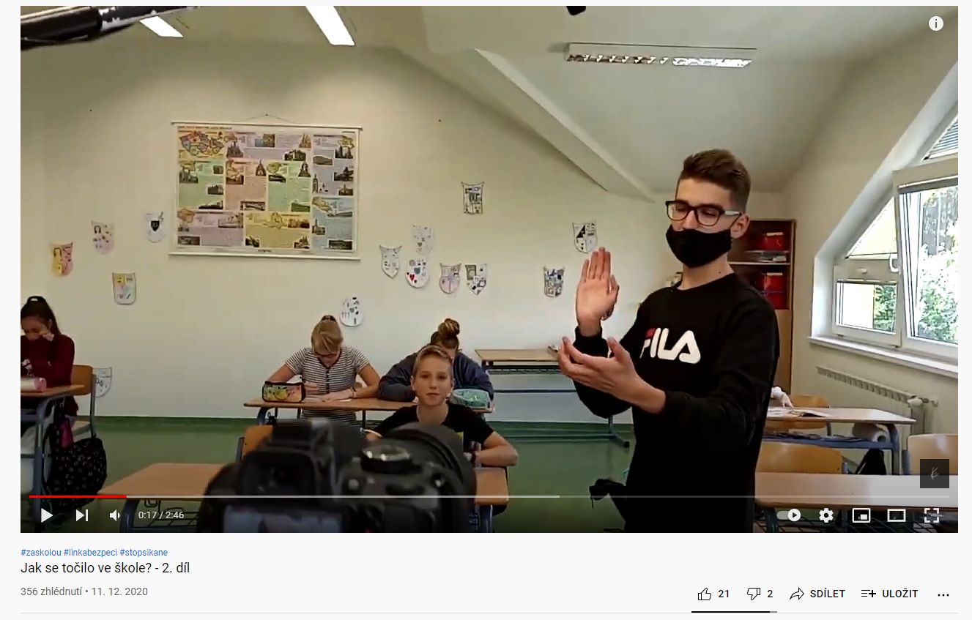
https://www.youtube.com/watch?v=I1OVHFV6ids

Thanks

Finally, we would like to thank everyone who made this project possible. It enabled us to strengthen IT thinking and digital competences of primary school students and teachers.
Thank you:
Bildungsdirection für Wien / Vienna Directorate for Education, European office (Lead partner)
- Program: Interreg V-A Austria – Czech Republic
- Lužánky – leisure center Brno, contribution organization (P. Štípová, J. Mimlich, L. Baxant)
Of course, we must not forget our students, without whom this program would not be possible.
- Filip Kratochvíla
- Lenka Lačňáková
- Tomáš Gališ
- František Blaha
- Lucie Doležalová
- Ondřej Uherek
- Lukáš Cibulka
- Jan Riegl
- Kateřina Šeďová
And also to the newly arrived members, thanks to which the DigiMe project will continueNatálie Kratochvílová,
- Valerie Bábíčková
- Michal Prát
- Tomáš Jančík
- Petr Studený
- Klaudie Malá
- Kryštof Koníček

Pavel Prošvic
Michal Vybíral

